***Task***

1. Login in using these credentials:

Username : TestID

Password : test

1. Add a new case, copy paste the format below in the textbox:

Name = Test

surname = Pettry

address = eruditi, prospect street, Hatfield, Pretoria, 0028

cell number = 0123456789

call back number = 0789456123

client type = home owner

service type = installation

reason = require new geyser

1. Add a new plumber.
2. Scan barcode on the app.
3. Take 5 images on the app.

Consent Form

Department : Computer Science

The purpose of this usability test is to determine whether our system is simple to use and navigate as well as whether it meets the user’s needs and requirements.

You will be asked to perform a set of tasks on our system to show us how you are using the system and then complete a feedback form.

I understand that my participation in this project will involve testing the functionality of the system and answering a feedback form. The test will take approximately 5-10 minutes to complete.

I understand that my participation in this research is voluntary and I can withdraw from the study at any time without having to provide reasons for doing so. Furthermore, any concerns I have may be freely discussed with Janaki Patil ([u16006110@tuks.co.za](mailto:u16006110@tuks.co.za)).

I understand that all the data collected will remain anonymous and all personal information provided by me will held confidentially. All data gathered from this study will be used solely for the purpose of this research.

I have read and understood all the information on this form and consent to being a part of this research.

Signature Date

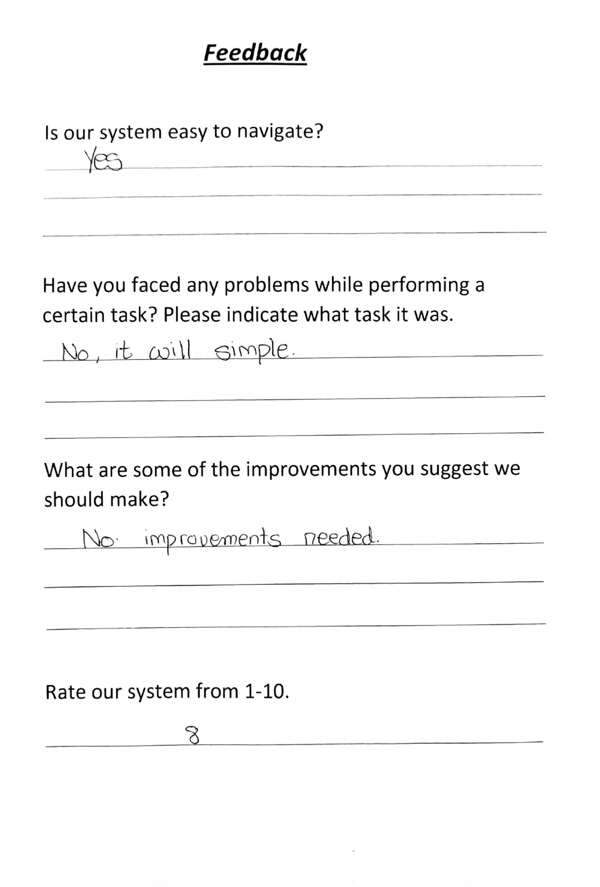

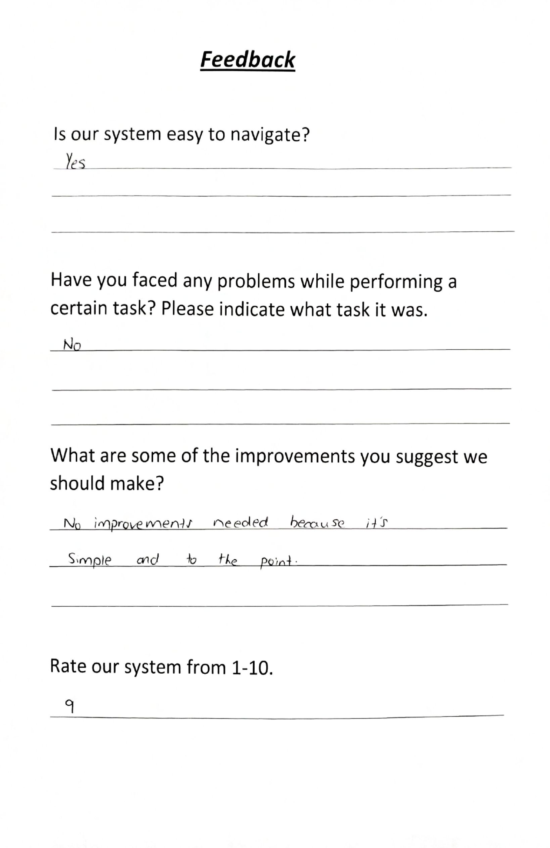

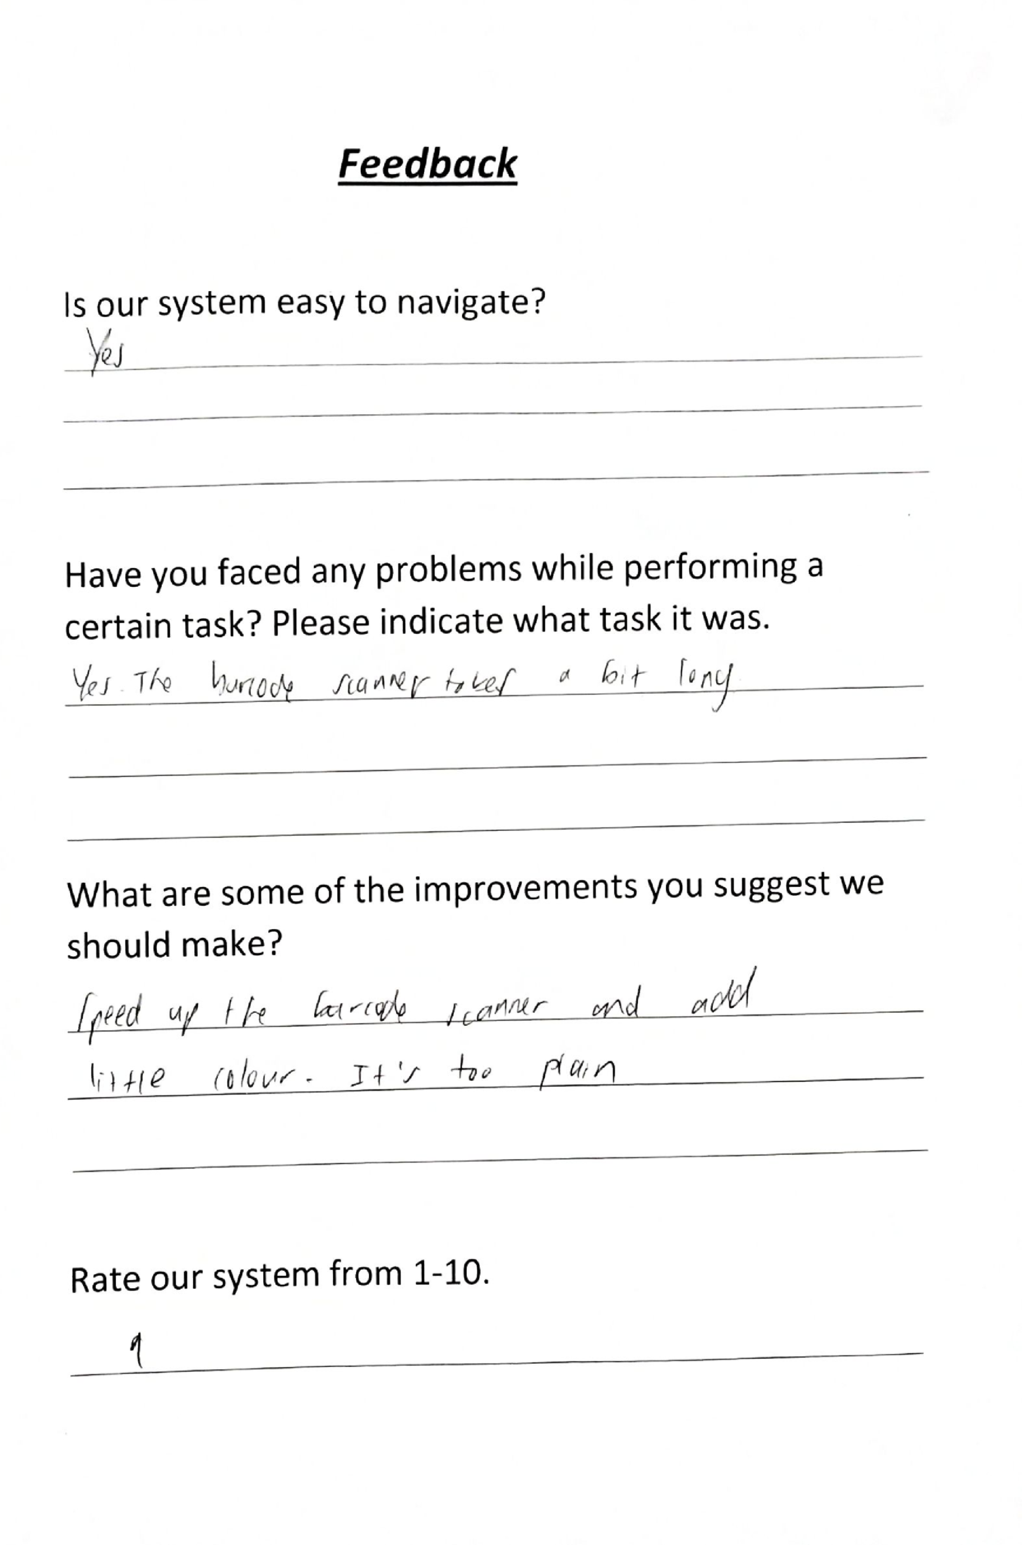

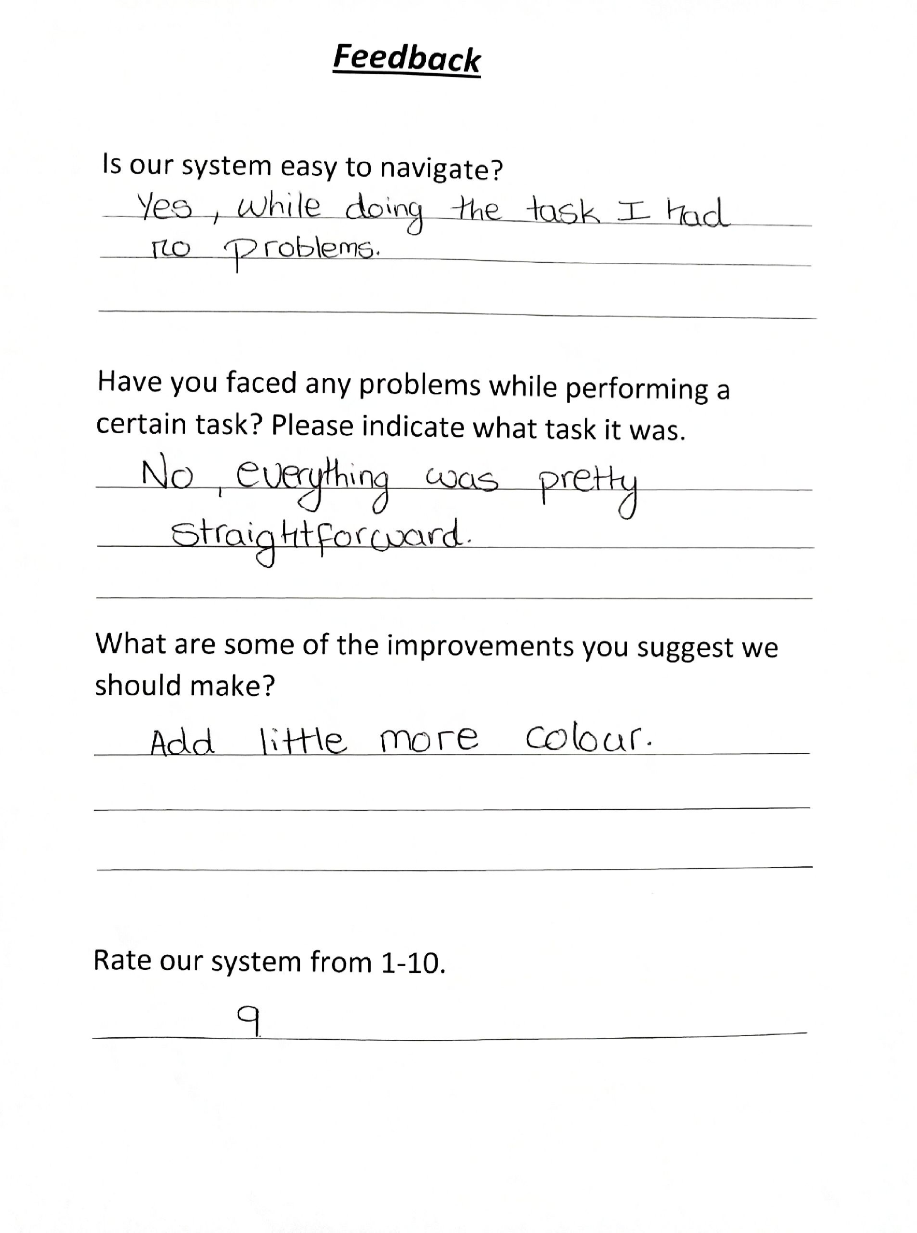

***Results***

We discovered that our system was easy to use and no one had a problem while navigating through it. They performed the task within 3 minutes. Some of the improvements the users suggested were to add more colour to the forms and make the barcode scanner to work faster. Other than that the system was good. The overall rating was 8/10.